Model Overview

* 2 separate models, one for lungs and one for airways
  + The loss function I use for image segmentation only works when classes are mutually exclusive, so 2 models are needed when masks overlap
* 256 x 256 x 1 input images (greyscale).
  + Trained on 26*500 images (resampling was allowed, some Nifti files had < 250 images)
* 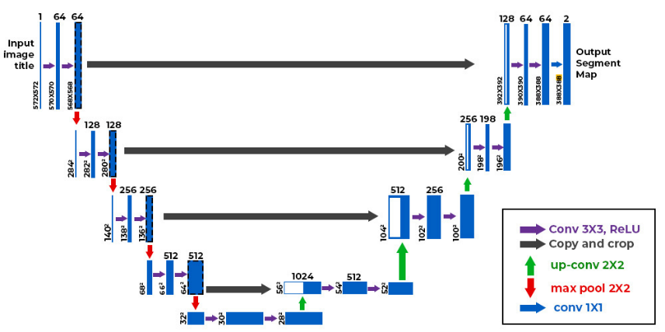U-Net Architecture
* Adam optimizer, learning rate = 0.001
* Batch norm for each layer
* 1 - Dice Coefficient for model loss
  + Per-pixel segmentation accuracy
    - 0 (worst) to 1 (best)
    - Loss = 1 – Dice Coefficient
* 5 epochs, 32 batches
  + ~ 25 min per epoch on my computer

**Model Test Accuracy (20% split)**

* Lung model Dice coefficient: 0.993
* Airway model Dice coefficient: 0.990

**Image 27 Accuracy**

* Lung model Dice coefficient: 0.614
  + poor accuracy on first images (lowest z-axis values)
* Airway model Dice coefficient: 0.197
  + Probably need to tweak loss for Airway segmentation and weigh airway classification higher than background classification